**Hello World SOAP Web Service**

**Towards Web Service**

Right click on project name, select ‘New’ and then select ‘Web Service’

[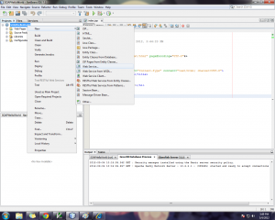](http://javapapers.com/wp-content/uploads/2012/03/4NewWebService.png)

Type ‘Web Service Name:’ as “HelloWorld”, then type ‘Package:’ as “com.javapapers.webservice” and click Finish.

[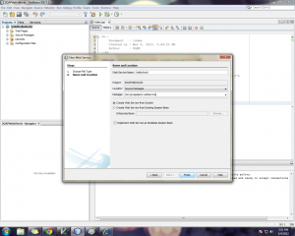](http://javapapers.com/wp-content/uploads/2012/03/5HelloWorldWebService.png)

Thats it! Web service development is done! Oh my God this is too much. Is that so easy?? Till now, we have heard a lot about web services but we never thought of it to be so easy! Wait wait, before we relax..

NetBeans has created this SOAP based hello world web service. Lets understand what it has done in the background and verify if it is working.

**Service Code**

Following is the java code that serves as the web service and it is generated by Netbeans.

/*

* To change this template, choose Tools | Templates

* and open the template in the editor.

*/

package com.javapapers.webservice;

import javax.jws.WebService;

import javax.jws.WebMethod;

import javax.jws.WebParam;

/**

*

* @author USER

*/

@WebService(serviceName = "HelloWorld")

public class HelloWorld {

/**

* This is a sample web service operation

*/

@WebMethod(operationName = "hello")

public String hello(@WebParam(name = "name") String txt) {

return "Hello " + txt + " !";

}

}

hello is the operation that returns “Hello” + the parameter sent as argument.

**WSDL of Web Service**

Now right click the project and click run. Then type the following url in the browser

http://localhost:8080/SOAPHelloWorld/HelloWorld?wsdl

it will return the wsdl of the soap web service that we have created now. This wsdl contains,

* xml definition
* XSD schema import
* Two message tags hello and helloResponse (request and response)
* Porttype definition including operation hello
* Binding describes, we use soap, then operation, input and output.
* Service definition, name, port and address for invocation.

**Web Service Client**

Now lets invoke this webservice and see how it works.  
Open the index.jsp that was generated by NetBeans

[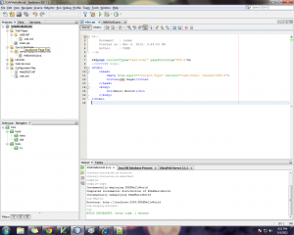](http://javapapers.com/wp-content/uploads/2012/03/6HelloWorldJSP.png)

Remove the “Hello World!” string. We are going to access the now created soap web service in the place and print whatever the web service returns.

Right click on the project and choose ‘New’ then ‘Web Service Client…’

[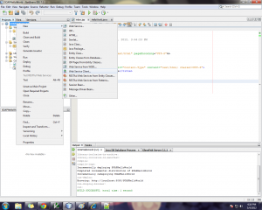](http://javapapers.com/wp-content/uploads/2012/03/7NewWebServiceClient.png)

In the New Web Service Client dialog select ‘WSDL URL:’ and type the wsdl url in the text box ‘http://localhost:8080/SOAPHelloWorld/HelloWorld?wsdl’. Then in package, type com.javapapers.webserviceclient and click Finish.

[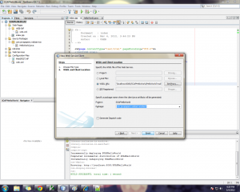](http://javapapers.com/wp-content/uploads/2012/03/8WebServiceClient.png)

**Invoke the Web Service**

Now the web service client is ready. We need to invoke the hello world soap web service using the web service client we have created now.

In that place right click choose “Web Service Client Resources” then select “Call Web Service Operation…”

[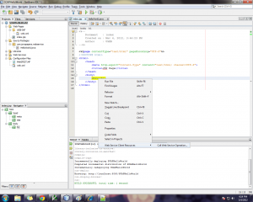](http://javapapers.com/wp-content/uploads/2012/03/9CallWebServiceOperation.png)

From that dialog select “hello” and clik ok. This is the operation we are invoking of that web service.

[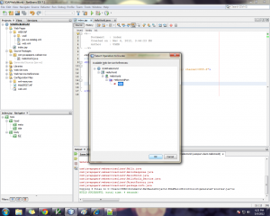](http://javapapers.com/wp-content/uploads/2012/03/10SelectOperation.png)

Following is the code snippet inserted by Netbeans IDE to access the web service.

<% try { com.javapapers.webserviceclient.HelloWorld_Service service = new com.javapapers.webserviceclient.HelloWorld_Service(); com.javapapers.webserviceclient.HelloWorld port = service.getHelloWorldPort(); // TODO initialize WS operation arguments here java.lang.String name = ""; // TODO process result here java.lang.String result = port.hello(name); out.println("Result = "+result); } catch (Exception ex) { // TODO handle custom exceptions here } %>

In the above code snippet, for vaiable ‘name’ assign a string value you prefer like,

java.lang.String name = "javapapers";

Right click the project and select ‘run’ and you get “Result = Hello javapapers ! ”

[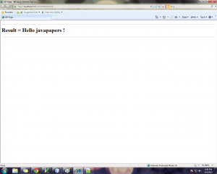](http://javapapers.com/wp-content/uploads/2012/03/11HelloWorld.png)

You can [download the complete source – SOAPHelloWorld](http://javapapers.com/wp-content/uploads/2012/03/SOAPHelloWorld.zip) of this article.